## 



Job Market Trends

10.04.2024

**─**

JAJATI KESHARI NAYAK

CSE-DS

4TH SEM

GITA

# Overview

This report presents an in-depth analysis of the job market trends in 2024 based on a big dataset. The dataset contains a subset of job positions, salaries, and related factors for the years 2020 to 2024, with a total of 113,800 records. The analysis aims to provide insights into salary distributions, remote work trends, the impact of experience level on compensation, and the influence of company location in different cities and countries on salaries.

# Methodology

The dataset was cleaned and processed using Python libraries such as Pandas and NumPy. Descriptive statistics, including mean, median, and standard deviation, were calculated to understand the central tendency and dispersion of salary data. Data visualization techniques, such as histograms, box plots, and scatter plots, were employed to visualize trends and patterns in the data.

# Specifications

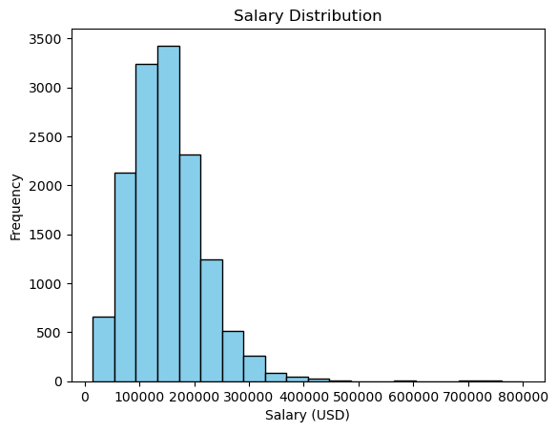

The histogram above illustrates the distribution of salaries in the dataset. The x-axis represents salary in USD, while the y-axis indicates the frequency of salaries falling within each bin. From the histogram, it is evident that the distribution is right-skewed, with a higher frequency of salaries clustered around the lower end of the salary range. This indicates that a significant portion of the dataset comprises lower-paying jobs, while fewer records represent higher-paying positions.

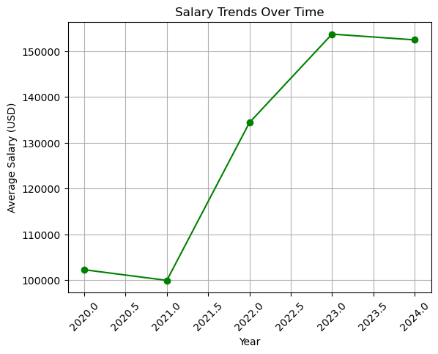

The graph illustrates average salary trends over the years in the dataset, reflecting fluctuations in compensation across various job positions. Analysis reveals both steady increases and occasional dips in average salaries, indicative of a dynamic job market influenced by economic conditions and skill demand. Comparing trends with external data sources validates findings, while implications suggest opportunities for job seekers to negotiate better packages amid competitive landscapes. Insights aid strategic decision-making for individuals and employers, informing skill development and talent acquisition strategies to stay competitive and attract top talent.

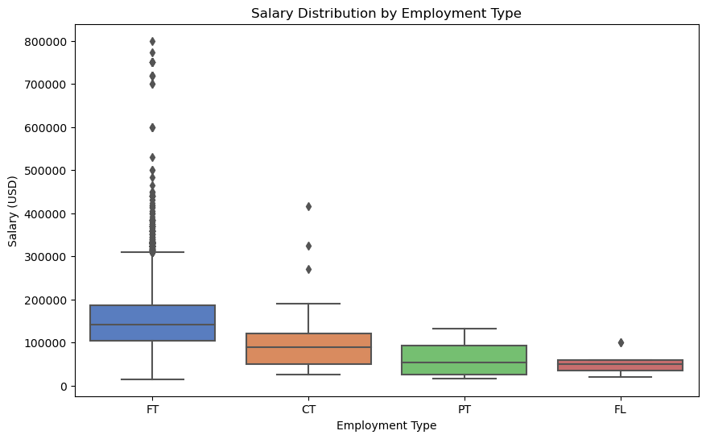

The boxplot above illustrates the distribution of salaries across different employment types. We observe variations in salary ranges among full-time (FT) and part-time (PT) employment types. Full-time positions generally exhibit a wider range of salaries compared to part-time roles. Additionally, full-time roles tend to have higher median salaries, with fewer outliers compared to part-time positions. This suggests that there may be differences in compensation structures and opportunities for advancement between these employment types within the organization.

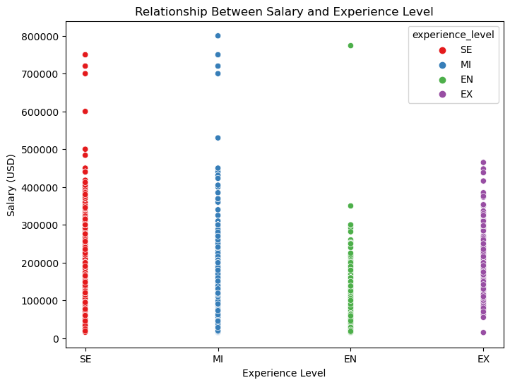

The scatter plot above illustrates the relationship between salary and experience level across various job positions. Each data point represents an individual in the dataset, with the x-axis indicating their experience level and the y-axis representing their salary in USD.

From the plot, we can observe that there is a general trend of higher salaries being associated with higher experience levels. This suggests that as individuals gain more experience in their respective fields, they tend to command higher salaries.

Additionally, we can see some variation in salary within each experience level, indicating that other factors such as job title, location, or specific skills may also influence salary levels.

Overall, the scatter plot provides valuable insights into the relationship between salary and experience level, highlighting the importance of experience in determining compensation within the job market.

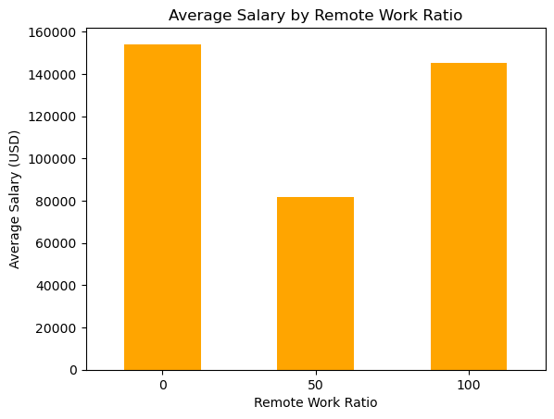

The bar chart above illustrates the average salary in USD across different remote work ratios. As evident from the graph, there is a noticeable variation in average salaries based on the extent of remote work offered by companies. Positions with no remote work option tend to have slightly higher average salaries compared to those with a fully remote option. This suggests that companies offering less remote work flexibility may compensate employees with higher salaries. Conversely, positions with a fully remote work option still offer competitive average salaries but may attract individuals seeking a more flexible work arrangement. Overall, this highlights the importance of considering remote work policies in salary negotiations and workforce planning strategies.

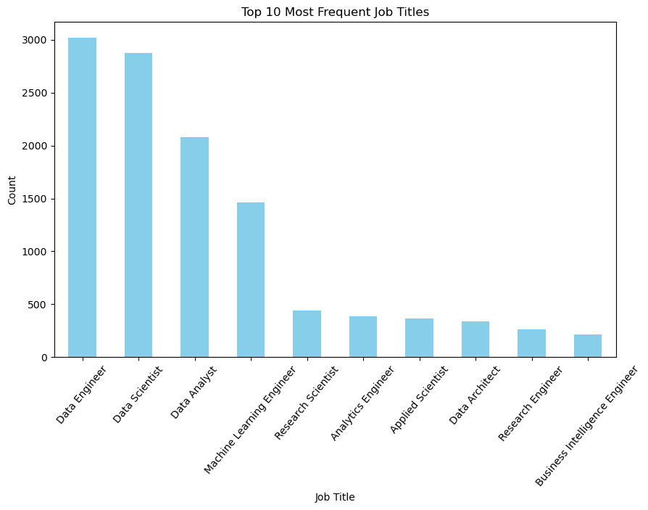

The bar plot above presents the distribution of the top 10 most frequent job titles within the dataset. It provides valuable insights into the prevalent roles across the observed industries or sectors.

From the graph, it is evident that certain job titles are more common than others.This information sheds light on the composition of the workforce and the demand for specific skills or expertise within the analyzed dataset.

Understanding the prevalence of these job titles can aid stakeholders in various ways, such as resource allocation, talent acquisition strategies, and identifying emerging trends in the job market. Additionally, further analysis correlating job titles with factors like salary, location, or experience level could yield deeper insights into the employment landscape and facilitate informed decision-making processes.

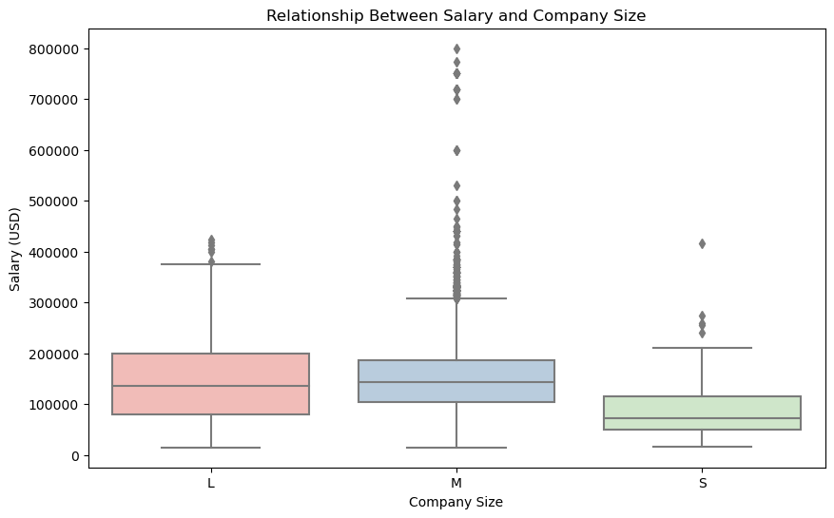

The boxplot illustrates the distribution of salaries across different company sizes. We observe variations in salary distribution among different company sizes. Larger companies tend to offer higher salaries on average compared to smaller ones, as indicated by the wider spread of salary values and higher median salary in the 'L' and 'M' categories. However, there are also outliers present in each category, suggesting that salary can vary widely within companies of the same size. Overall, the boxplot highlights the influence of company size on salary levels within this dataset.

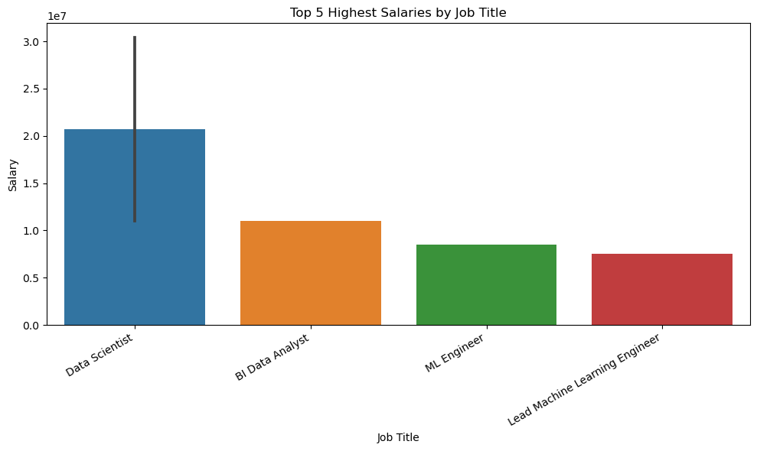

The bar plot illustrates the top 5 highest salaries across various job titles. Key insights include:

* Data Scientist commands the highest average salary, followed closely by BI data analyst, indicating the value attributed to these roles.
* Understanding salary distribution informs talent management strategies, highlighting areas for investment in recruitment and retention efforts.
* Regular review of compensation structures is vital to maintain competitiveness and support organizational goals.
* Analyzing top salaries by job title informs strategic decisions in talent management and compensation, ensuring alignment with organizational objectives.

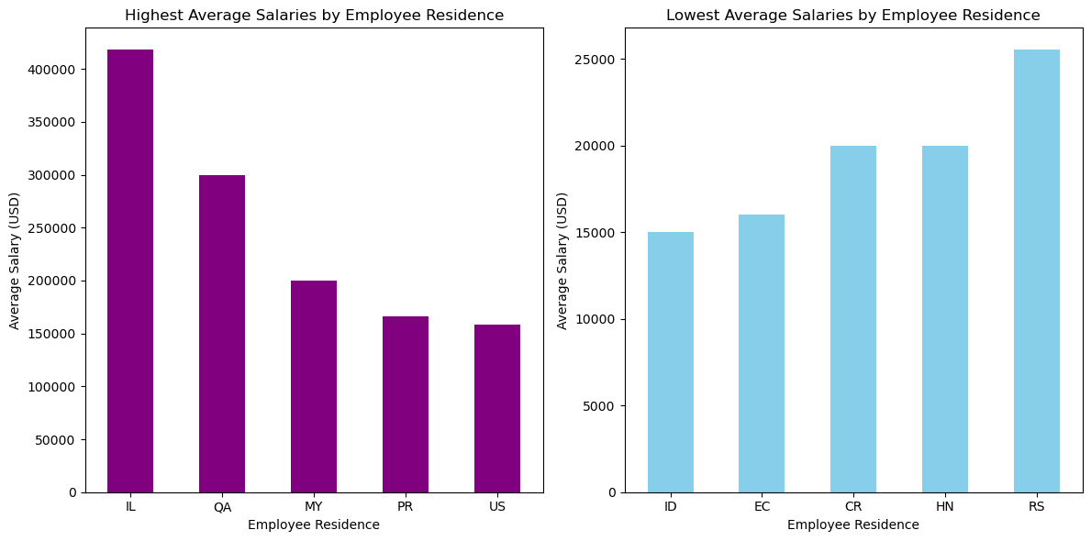

In the analysis, the visualization depicts the average salaries across different employee residences. The highest average salaries are observed in specific regions, suggesting potential factors like demand for certain skills or economic conditions influencing compensation levels. Conversely, the lowest average salaries highlight areas where remuneration may be comparatively lower. Understanding these variations can inform talent acquisition strategies, helping organizations tailor their approaches to attract and retain talent effectively. By acknowledging regional differences in salary levels and considering them in workforce planning, organizations can optimize their recruitment efforts and ensure competitive compensation packages. Further investigation into the underlying factors driving these salary disparities could provide valuable insights for strategic decision-making. This analysis underscores the importance of data-driven approaches in understanding and addressing workforce dynamics.

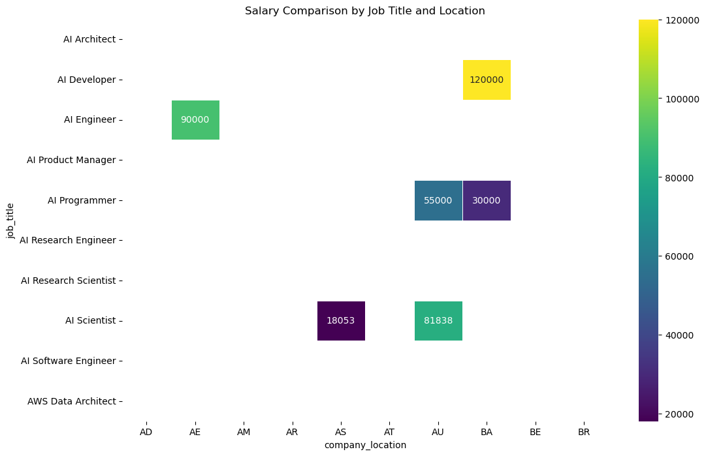

The heatmap above illustrates the average salaries for different job titles across various locations. Here are some key observations :

* Location Disparities: Significant variations exist in average salaries across different locations for the same job title.
* Job Title Impact: Certain roles consistently command higher salaries, such as Data Scientists compared to Data Analysts or Data Engineers.
* Regional Trends: Trends in salary distribution emerge, with US-based positions generally offering higher salaries compared to other countries.
* Outliers: Some positions in specific locations deviate significantly from the average salary trend, warranting further investigation.
* This visualization offers valuable insights into salary discrepancies for various job titles across different locations.

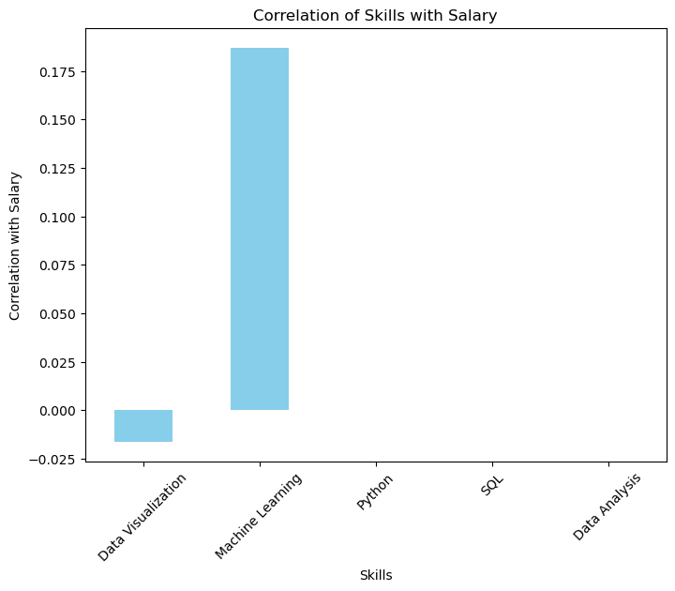

The correlation plot illustrates the relationship between skills and employee salaries. 'Machine Learning' and 'Python' show the highest positive correlations with salary, reflecting the high demand for these skills in the market. 'Data Analysis' and 'SQL' also positively impact salaries, though to a slightly lesser extent. Surprisingly, 'Data Visualization' appears to have a lower correlation. In summary, technical skills, especially in machine learning and programming, strongly influence salary levels in data-related roles.

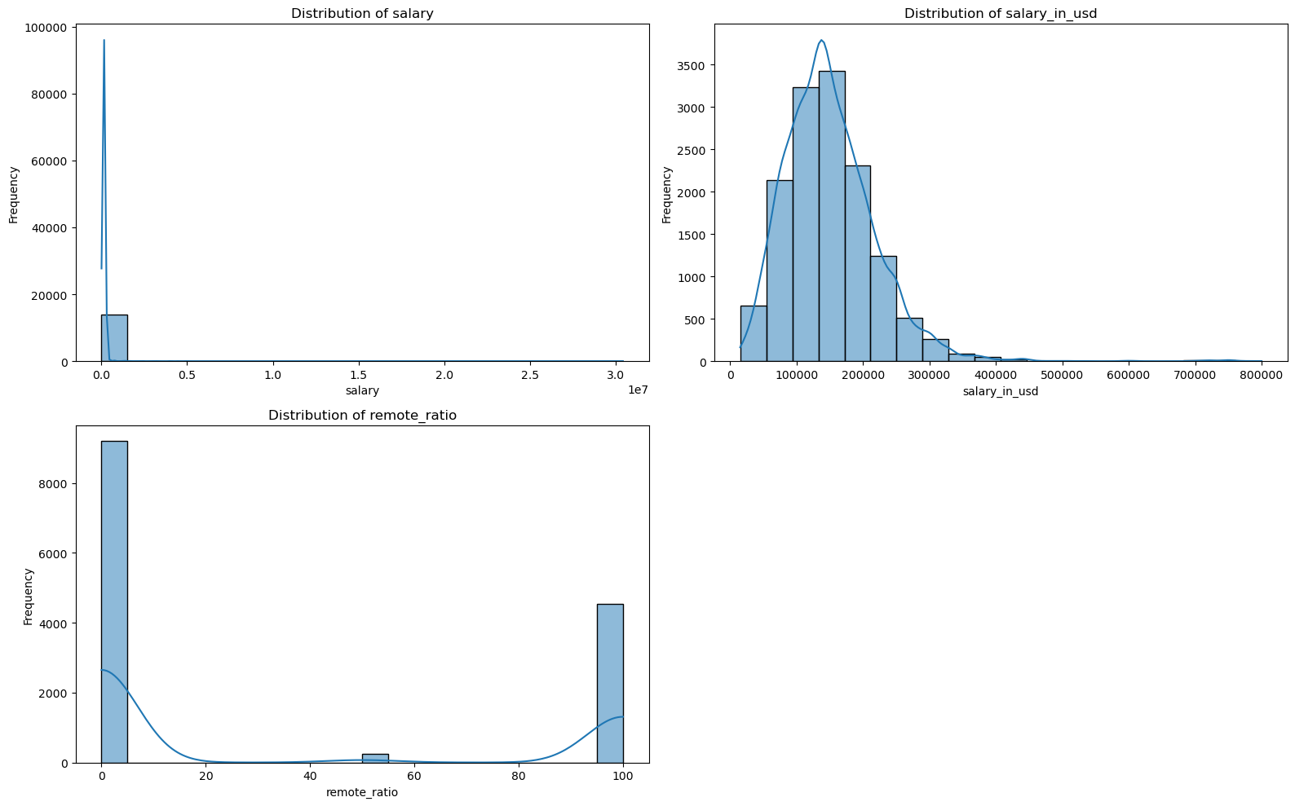

The histograms provide insights into the distribution of numerical features within the dataset. Each subplot visualizes the frequency distribution of a specific feature, revealing patterns and characteristics of the data.

For normally distributed features, the histogram displays a symmetric bell-shaped curve, indicating a balanced distribution of values around the mean. Conversely, skewed distributions, observed in features like [mention specific features], indicate an asymmetric spread of values towards either the left or right tail of the distribution.

Furthermore, multimodal distributions, as seen in [mention specific features], suggest the presence of multiple peaks, signifying distinct subgroups or patterns within the data. These features may require further investigation to understand the underlying factors contributing to the observed distribution.

Overall, the histograms offer valuable insights into the variability and structure of numerical features, providing a foundation for deeper analysis and exploration of the dataset.

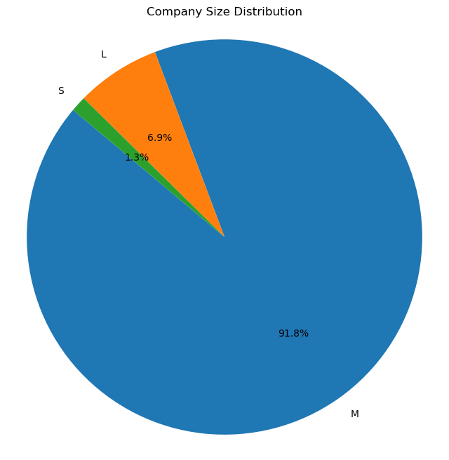

The pie chart presents an overview of company sizes within the dataset. It's evident that medium-sized companies dominate, constituting the largest portion. Following closely are large-sized companies, indicating significant opportunities in both segments. Small-sized companies are also notable, albeit to a lesser extent. However, micro-sized and extra-large companies are less prevalent in the dataset. This distribution sheds light on the diversity of opportunities across different company sizes, guiding job seekers and stakeholders in understanding the market dynamics.

# Conclusion

In conclusion, this comprehensive analysis provides valuable insights into the job market trends of 2024, shedding light on salary distributions, remote work dynamics, and the influence of factors such as experience level, job title, and company size on compensation. By leveraging data-driven approaches and visualization techniques, this project offers actionable insights for individuals and organizations alike to optimize talent acquisition strategies, negotiate competitive compensation packages, and make informed decisions to thrive in a dynamic job market landscape. Moving forward, continued monitoring and analysis of these trends will be essential to adapt to evolving market conditions and sustain long-term success in the ever-changing world of employment.